Lab #5: Calculating Area, Proportions and Basic Statistics

Objective
This lab will guide you through calculating the areas of NYC housing building complexes that fall within different Census Tracts and performing basic statistical analysis (mean, median, total areas) on these spatial intersections using QGIS and R.

Part 1: Using QGIS to Calculate Housing Buildings Complex Areas within Census Tracts
Step 1: Setup and Data Acquisition
Step 2: Load Data into QGIS
- Open QGIS and go to Layer > Add Layer > Add Vector Layer to load both the NYCHA housing buildings (NYCHA_developments_July2011.shp) and census tracts (nyct2020.shp) shapefiles.
- Check and align the Coordinate Reference Systems (CRS) of the two layers to ensure consistency by right-clicking each layer, selecting Properties > Information, and looking at the CRS field. If the CRS differs:
  - Right-click the layer > Export > Save Features As > Choose a CRS like EPSG: 3857 (Web Mercator).

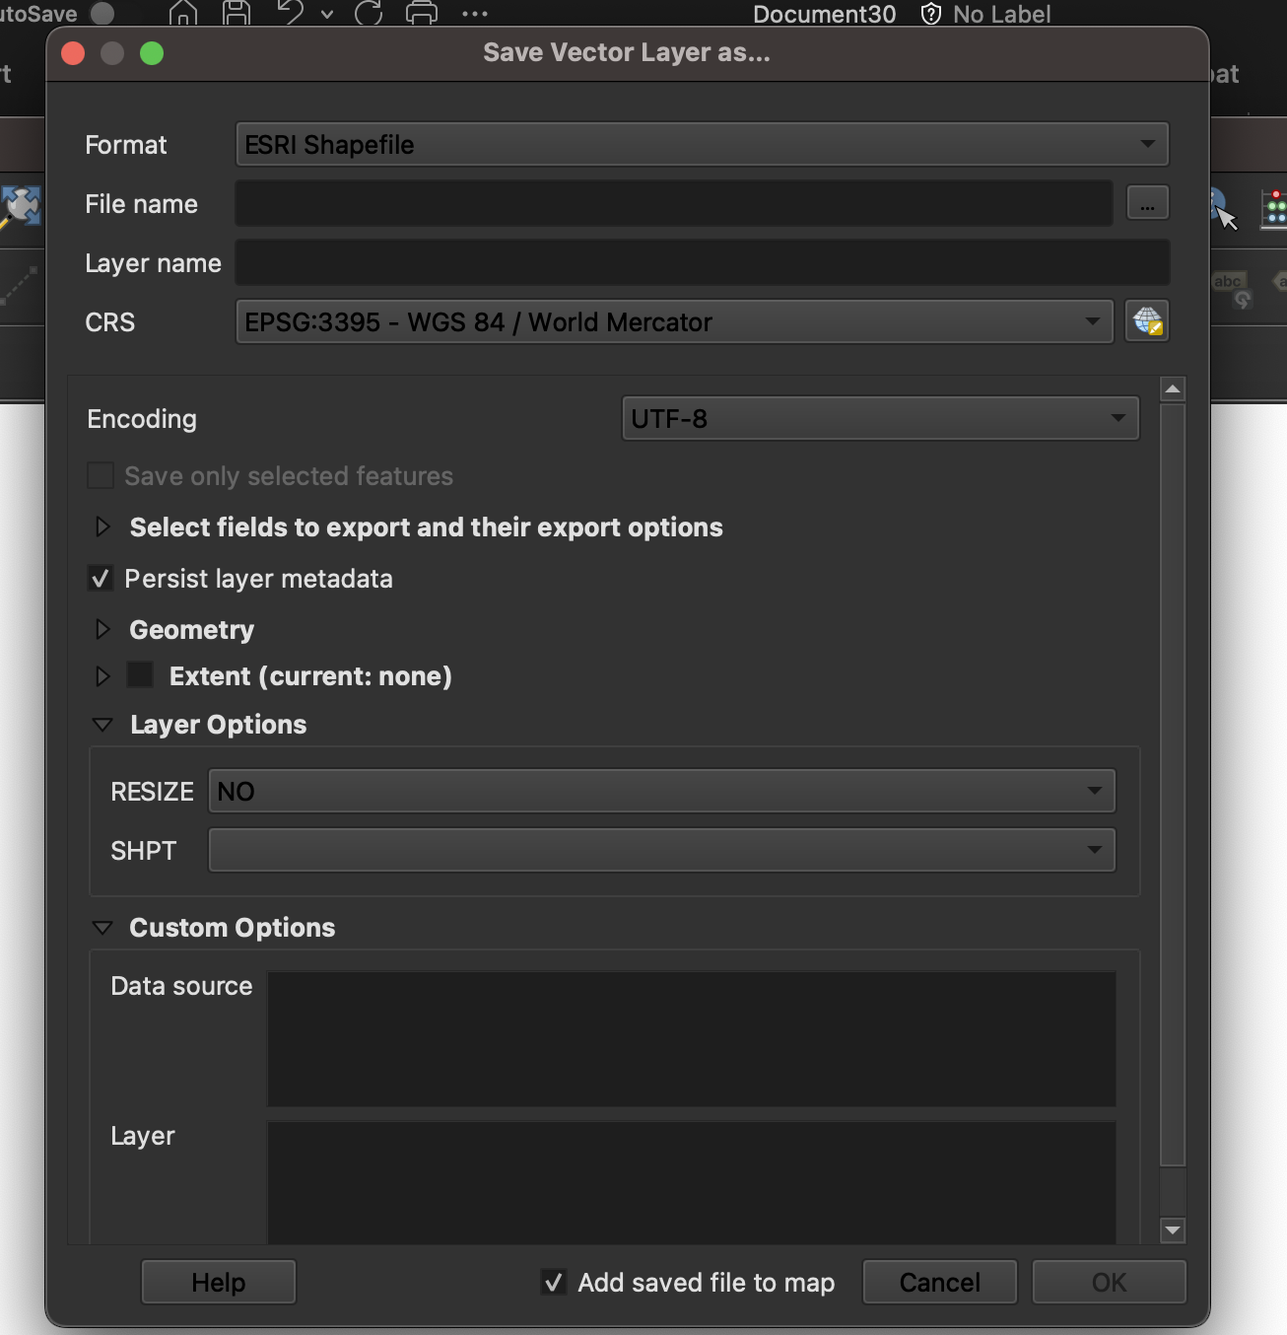

Step 3: Calculate the Areas of Housing Projects
- Add Area Field: Open the Attribute Table of the NYCHA housing building complexes layer.
- Click the Field Calculator (calculator icon) to create a new field for area (e.g., Project_Area).
- In the Field Calculator, enter the expression $area to calculate the area for each housing building complex.
- Save the new field.

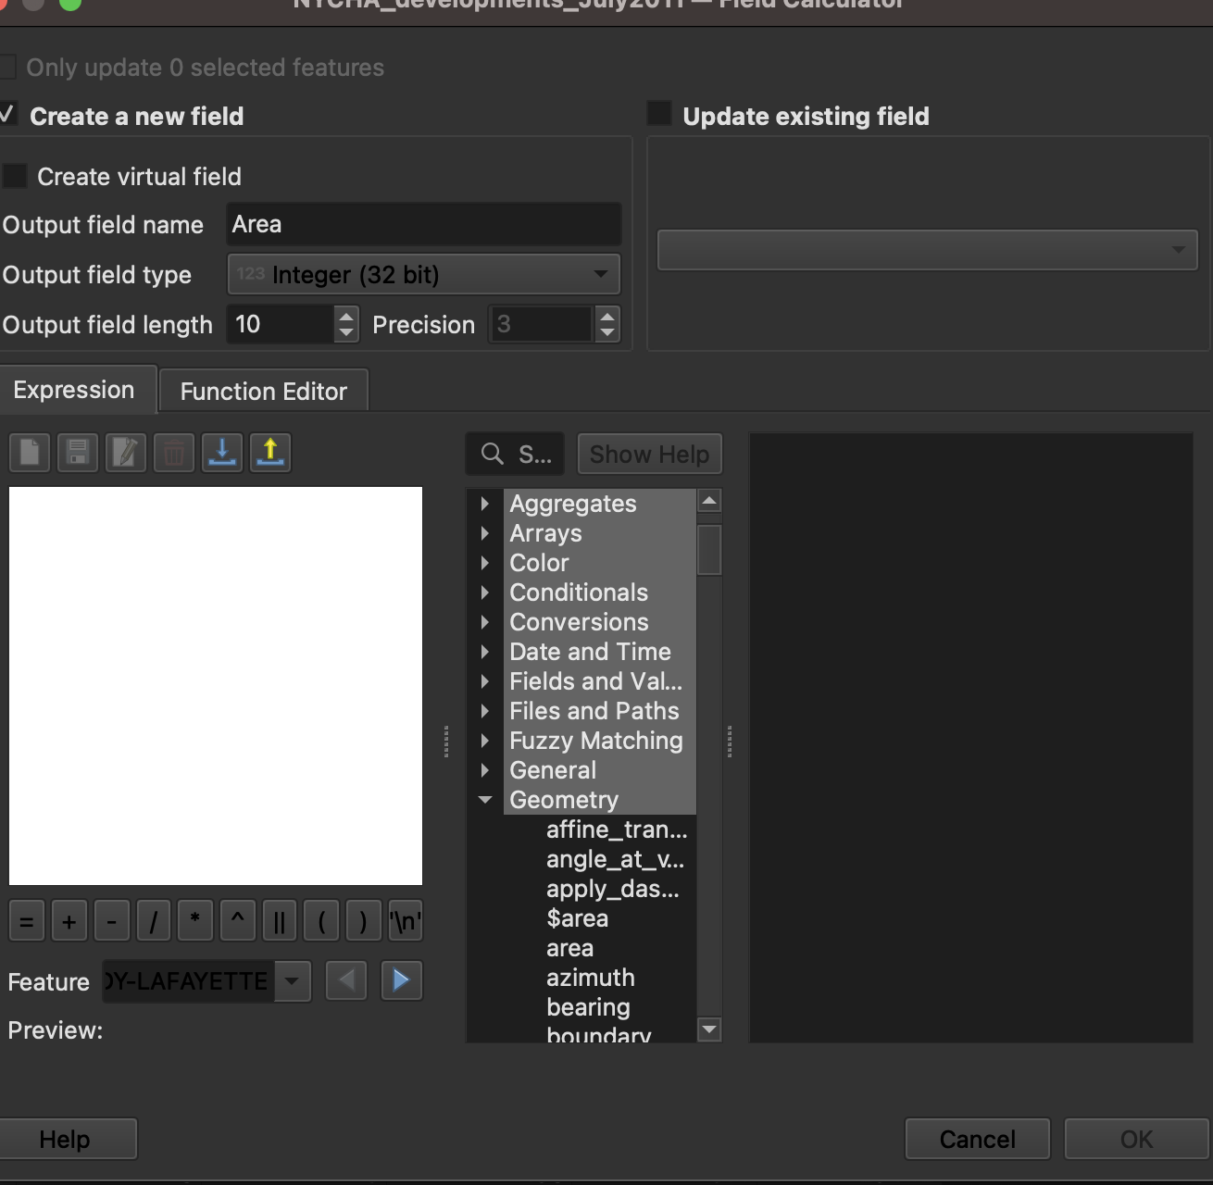

Step 4: Perform Spatial Intersection
- Go to Vector > Geoprocessing Tools > Intersection.
  - Input Layer: NYCHA Housing Projects
  - Overlay Layer: nyct2020
  - Output Layer: Choose a save location (e.g., NYCHA_Tracts_Intersection.shp).
- Click Run to perform the intersection, creating a new layer where each housing project is split by Census Tract boundaries.

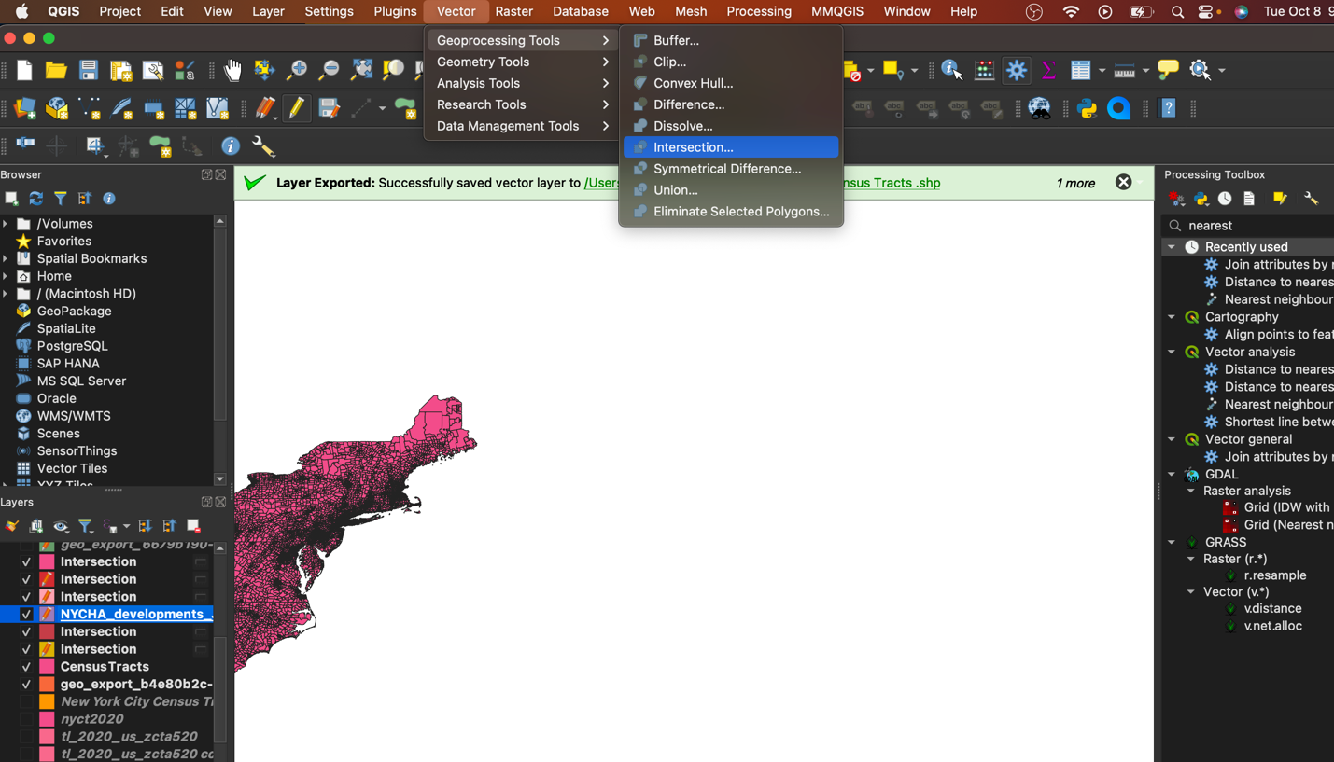

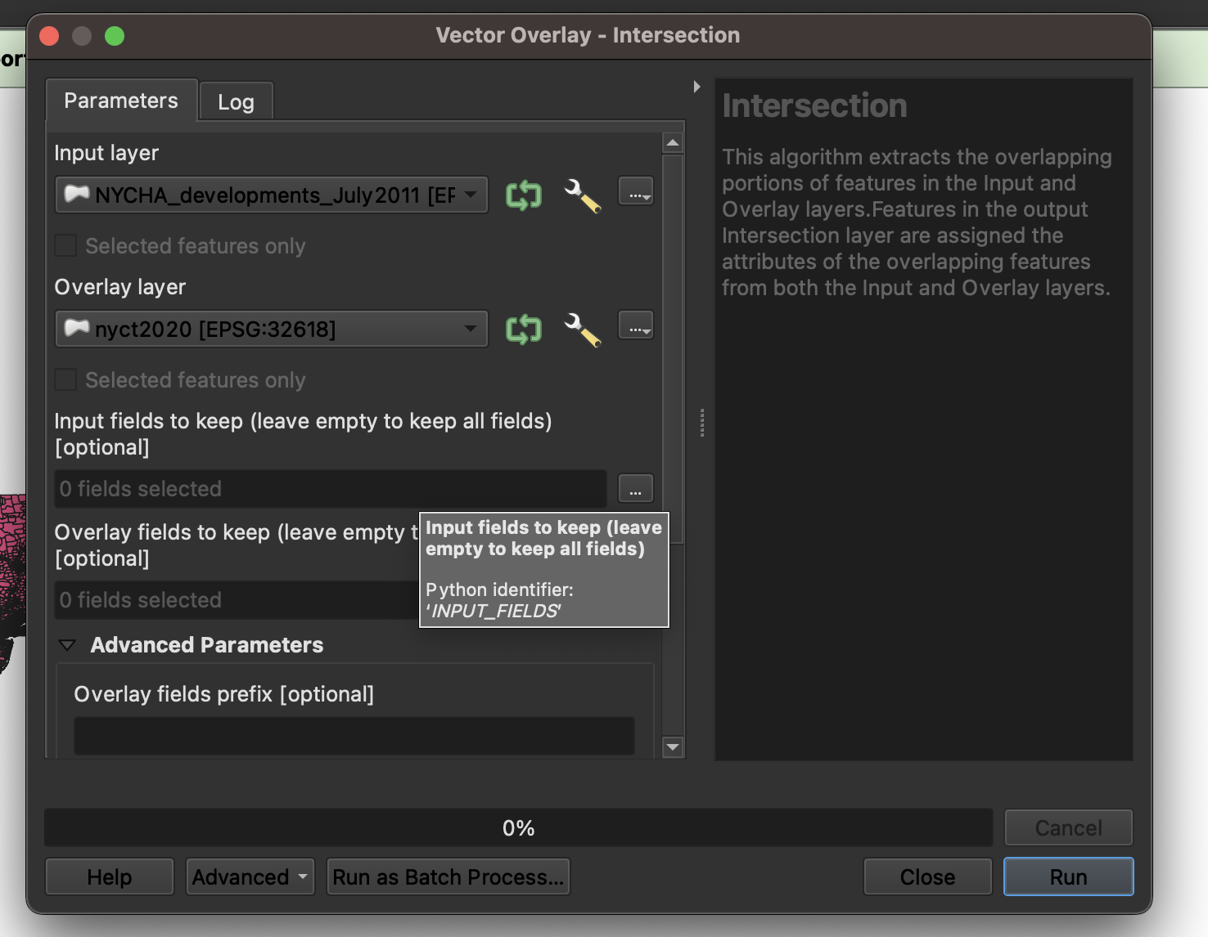
Step 5: Calculate the Overlapping Areas
- Open the Attribute Table of the intersection layer and click the Field Calculator.
- Create a new field (e.g., Overlap_Area) with the expression $area to calculate the area of each intersected polygon.

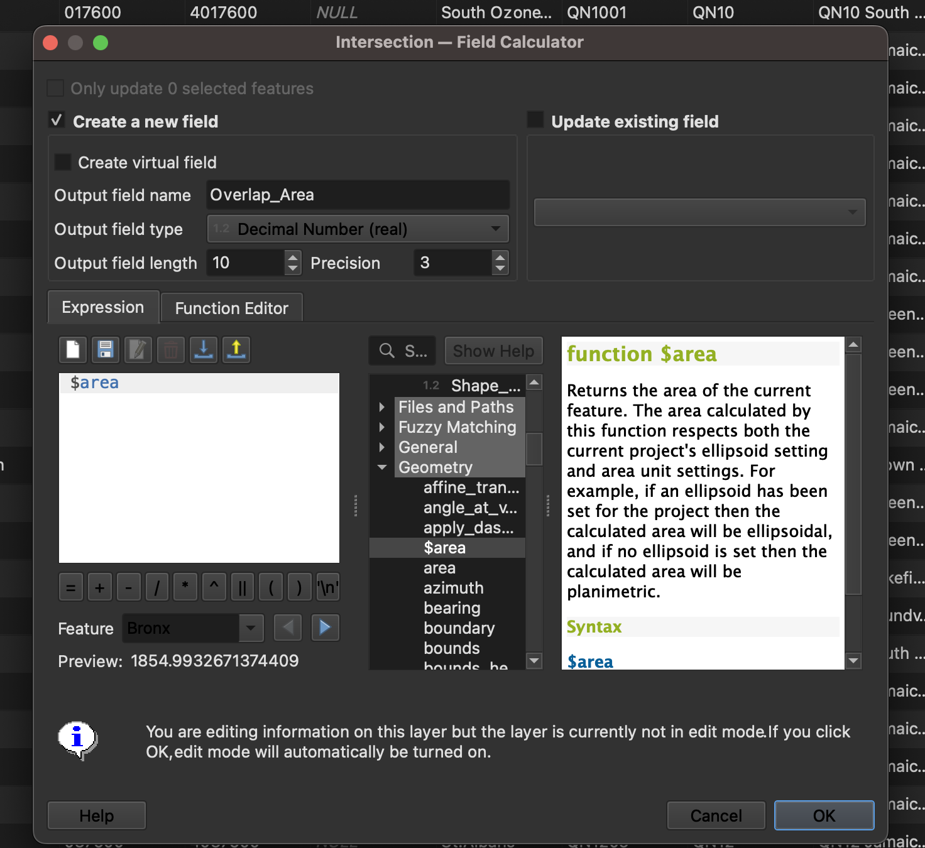

Step 6: Calculate the Proportion of Housing Project Area within Each ZCTA
- Add another field (e.g., Area_Percentage) to calculate the proportion of each housing project that falls within each tract
- Use the formula: ("Overlap_Area" / "Project_Area") * 100.

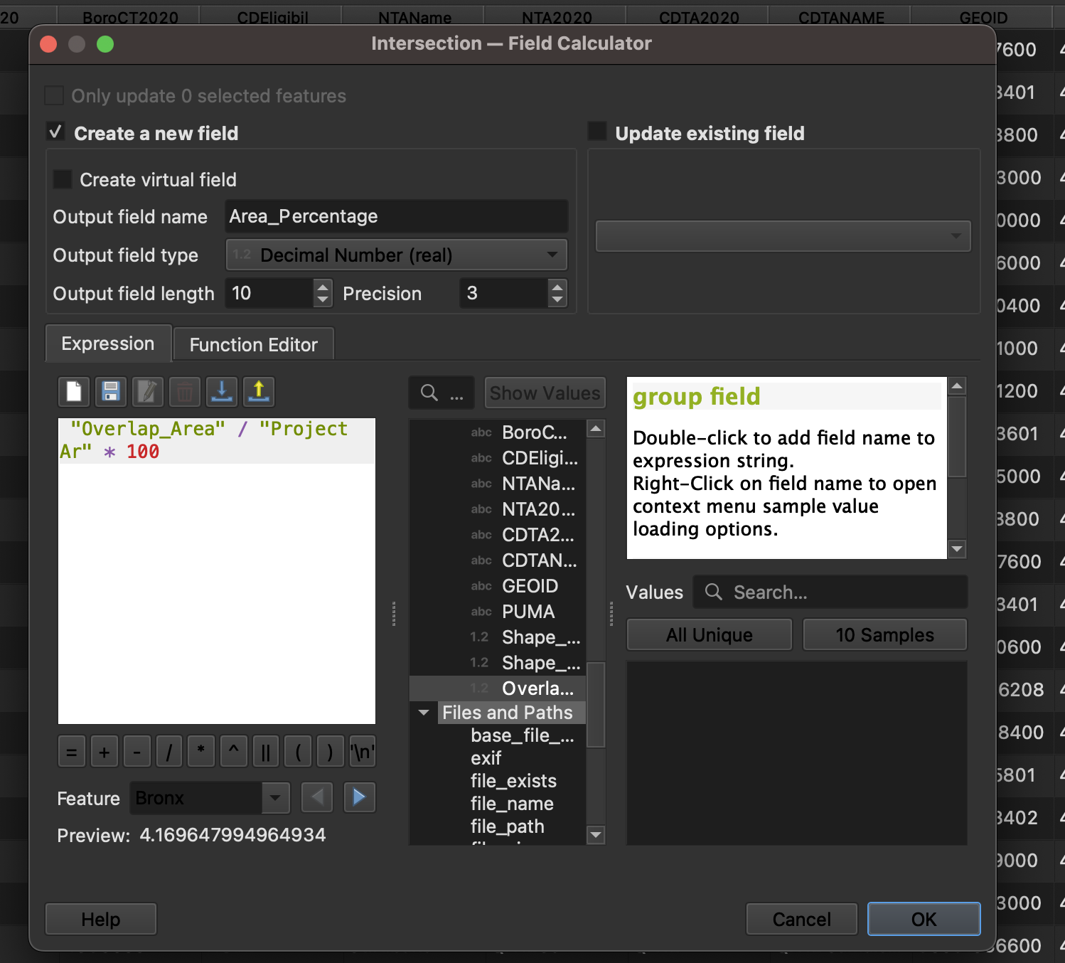

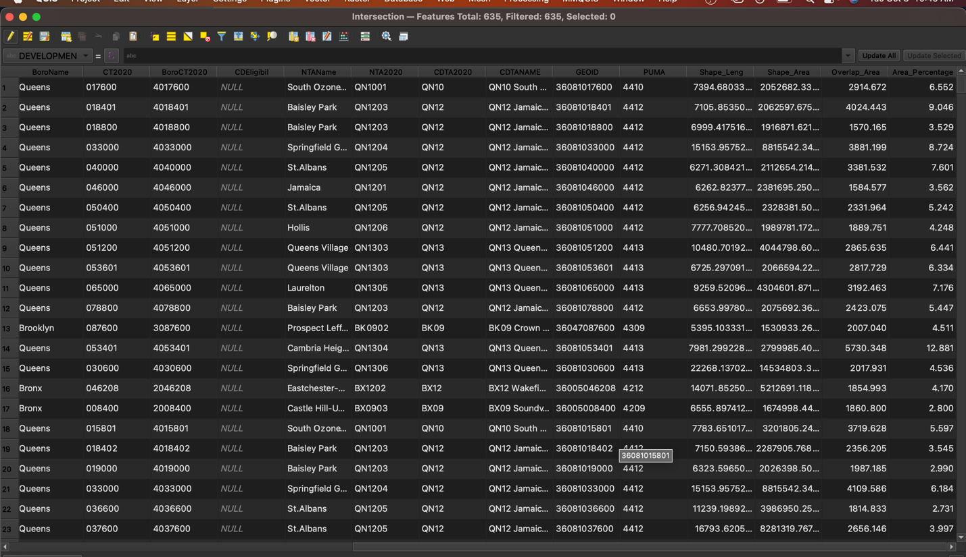

Step 7: Summarize the Data
- Go to Vector > Analysis Tools > Basic Statistics for Fields to compute statistics like mean, median, and total area for the overlapping areas.
- Apply these statistics to the Overlap_Area and Area_Percentage fields.

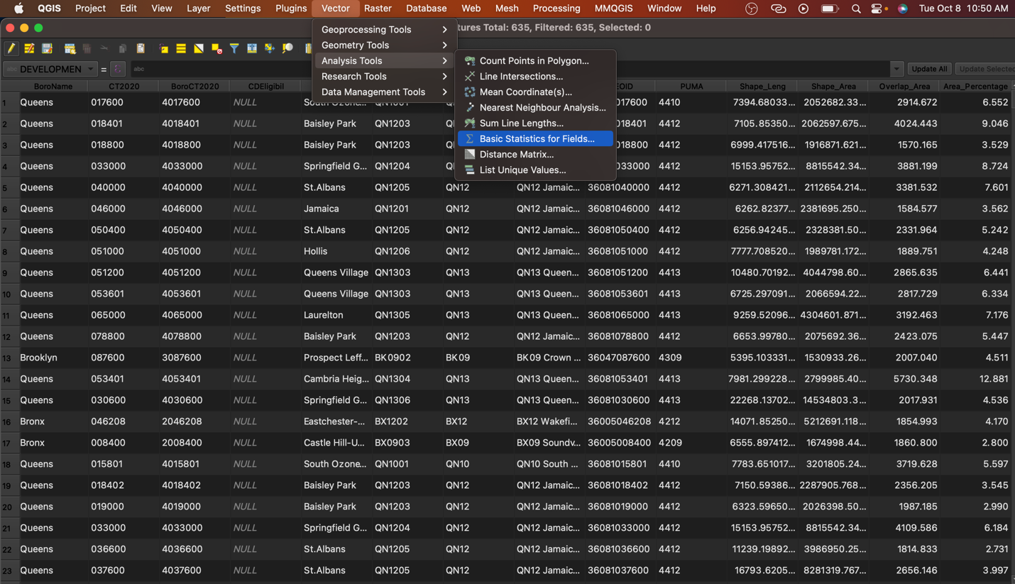

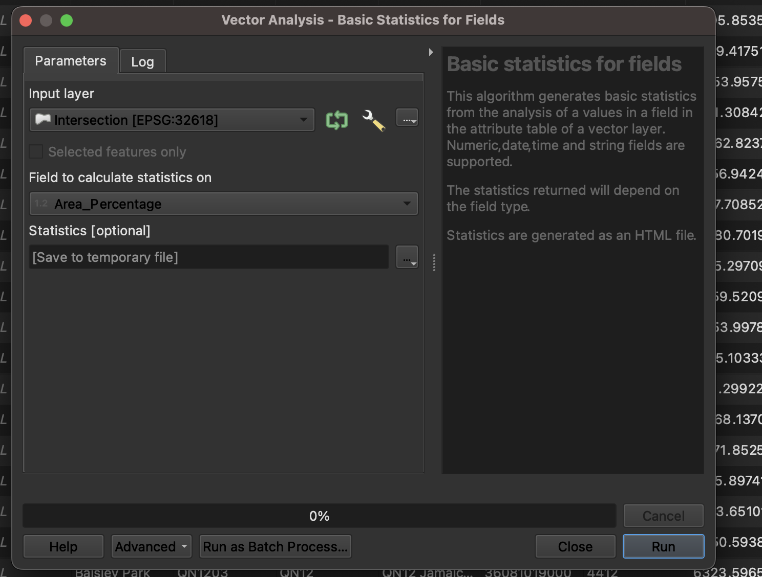

Submission:
- Make a table of all ZCTAs with NYCHA percentages over 50% of coverage. You should have a column for the NYCHA building, the Census Tract, the “Project Area”, the “Overlay Area” and the percentage of overlap.
- Submit a csv with the table on Canvas.
